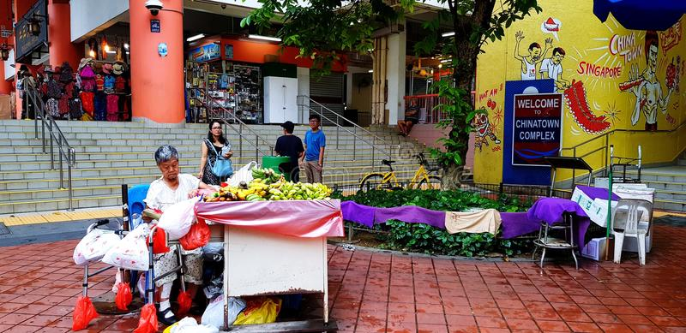
“Are you Jesus?”
Our God is God of surprises.
By Matthew Kelly
It was the biggest meeting of Paul’s life, and it had gone well. He couldn’t wait to tell his wife and his boss. As he rushed out of the Brooklyn office building with the rest of the team, they noticed a vacant cab – a rare sight during rush hour. Eager to get to the airport to catch their flight home, they bolted toward the cab, yelling to get the driver’s attention. But as they made their way across the sidewalk, they inadvertently knocked over a small produce stand. The rest of the team seemed oblivious until Paul stopped and turned around to go back. From beside the taxi the others called out to Paul, “Come on. You’ll miss your flight.” “Go ahead without me,” Paul replied as he made his way back across the street toward the sidewalk covered with produce. At that moment, he realized that the woman who had been behind the produce stand was blind. She was standing there crying softly with tears running down her face. “It’s OK, it’s OK,” Paul said to her as he got down on his hands and knees and began picking up the fruit and vegetables. There were a hundred people passing in each direction, but nobody else stopping to help. They just scurried off to wherever they were going. When the fruit was all back up on the stand, Paul began neatly organizing it, setting aside anything that was spoiled. Now he turned to the woman and asked: “Are you OK?” She nodded through her tears. Then, reaching for his wallet, he took out some bills and passed them to the woman, saying, “This money should cover the damages.” With that, Paul turned and began to walk away. “Mister,” the woman called after him. Paul paused and turned around. “Are you Jesus?” “Oh no.” he replied. The woman nodded and continued, “I only ask because I prayed for Jesus to help me as I heard fruit falling all over the sidewalk.” Paul turned to leave again, only now his eyes began to fill with tears. For a long time he wandered around looking for a taxi. After finally finding one, he sat in bumper-to-bumper traffic all the way to the airport. He had missed his flight, and because it was Friday night, all the other flights were full. Paul spent the night in a hotel by the airport. This gave him time to think. He couldn’t get one question out of his head.
When was the last time someone confused you for Jesus? How much is the sheer busyness of your life preventing you from living the life God is calling you to live?”
From Rediscover Jesus by Matthew Kelly

