Moses and the Burning Bush

(Exodus 3:1-15)

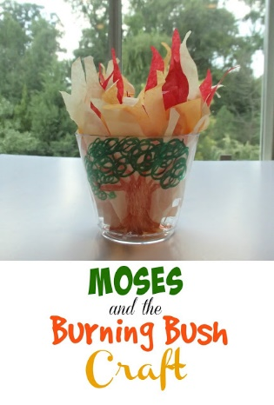
An easy craft for this lesson has been around for a long time. Sometimes the older, well tested ones are the best. I like that this one can cross over to many different age groups just by varying the style of the flames.

Materials:
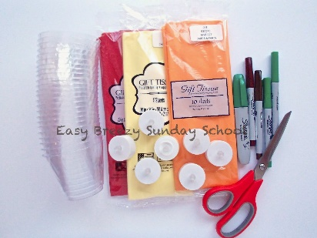

Clear plastic cups
Red, orange and yellow tissue paper
Brown and green Sharpies
Battery operated tea lights

At Home Before Prep:
Tools
Iron
Scissors
Ruler

1. With the setting on low, iron the tissue paper to get it nice and smooth.

2. Cut the tissue into 9"x 9" squares with the rotary cutter. Each child will need one square of each color.

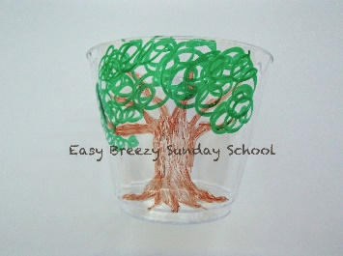
Instructions:
1. Draw and color a bush on the outside of a cup.

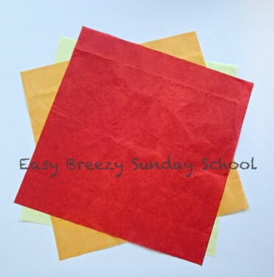

2. Layer the tissue yellow, orange and red with the corners alternating in direction.

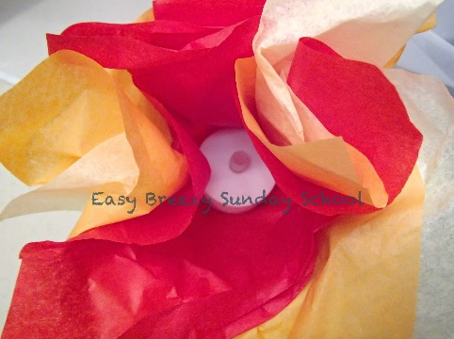
3. Turn on tea light and place in the center of the tissues.

4.Gather up the edges around the tea light to make a pouch.

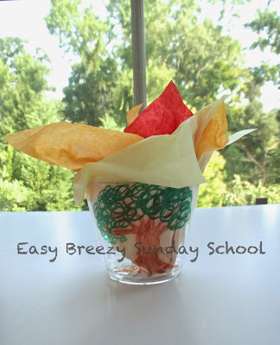
5. Place the pouch inside the cup and fluff out the edges of the tissue.
There you have it; your very own burning bush!

