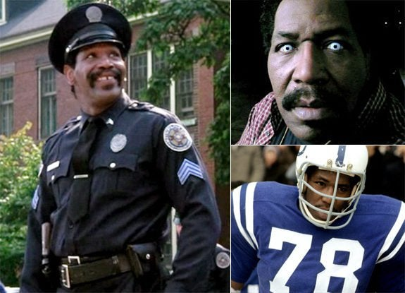

Jesus said, “Things that make people fall into sin are bound to happen but how terrible for the one who makes them happen!” Luke 17:1
The late Bubba Smith, former football star and actor, was also famous for his Miller-Lite beer commercials. In October 1985, his alma mater Michigan State made him the grand marshal of its Homecoming parade. Bubba was thrilled. As he rode through the student-lined streets, one side started shouting, “Tastes great,” The other side shouted back, “Less filling.” It was obvious that Bubba’s beer commercials were a hit. That night Bubba was so disturbed by excessive drinking among students he decided to stop making the commercials. He feared that he was influencing them to do something he didn’t want to be a part of. That decision cost Bubba a great deal of money, but he thought something greater was at stake.
How ready am I to get involved in the struggle against evil in the world?
We are our choices. Jean-Paul Sartre

From Challenge, by Mark Link, S.J.

